Chorley Council & South Ribble Council

Final
Internal Audit Report

Sundry Debtors – Aged Debts
2023/24

Audit Assurance: Limited
Auditor: David Holgate/Jacqui Murray
Date Issued:9th August 2023

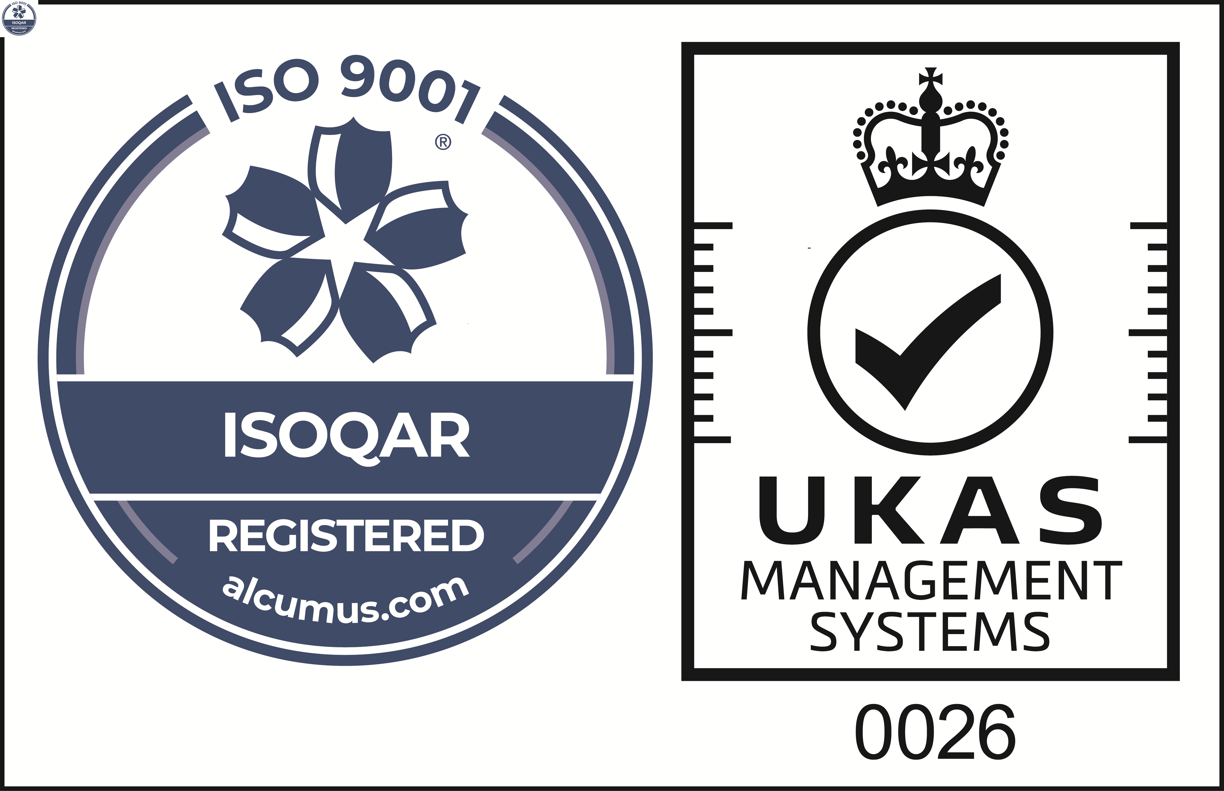
Cert No: 20128
ISO 9001

 | Reason for the Audit & Scope
1 | The sundry debtor system is the mechanism in place for the collection and recording sums of money due to the Council which is not accounted for by the specialist systems used for Council Tax and Non -Domestic Rates. The Council endeavours to recover all sundry income raised to maximise income, as failure to recover debt or identify balances for write off can impact on budget setting and available reserves.  This review will focus on the policies and procedures in place for the collection of aged debt to ensure compliance with the principles outlined within the Council’s Fair Collection Charter.  The review is included in the 2023/24 Annual Audit Plan approved by the Governance Committee on the 7th March 2023 at South Ribble and the 15th March 2023 at Chorley.

 | Audit Objectives
2 | The overall objective of the audit was to provide an opinion of the adequacy, application and reliability of the key internal controls put in place by management to ensure that the identified risks are being sufficiently managed.
3 | The audit also assessed the effectiveness of the various other sources of assurances using the three lines of defence methodology.
4 | The audit will focus on specific risks where the controls in place mitigate a gross red / amber risks to a residual green risk. In addition, all fraud risks and performance management data will be included within our work.

 | Audit Assurance
5 | A full risk-based review of Sundry Debtors has been undertaken regularly over the last 5 years. This review will focus solely on sundry debtor aged debts and adherence to the Fair Collection Charter to provide assurance or otherwise that debt recovery processes have been re-established after a period of suspension during Covid-19.
6 | The Head of Internal Audit is required to provide the Governance Committee with an annual audit opinion on the effectiveness of the overall control environment operating within the Council and to facilitate this each individual audit is awarded a controls assurance rating. This is based upon the work undertaken during the review and considers the reliance we can place on the other sources of assurance.
7 | A Fair Collection Charter (Charter) was formally approved by Full Council at each authority in February 2022 to ensure an ethical approach to debt collection including a more supportive recovery process and a reduction in the use of debt collection agencies however, further work is required to embed the principles of the Charter across both organisation’s as there was a general lack of awareness of its existence outside of the immediate Debtor Team. Widespread officer training on the Council’s debt recovery process has not been provided for a number of years. To improve awareness of the Charter and maintain focus on the collection of Council income, policies and procedures should be reviewed and relaunched, and training provided to all service areas with debt recovery responsibilities.  Our review identified that the finance system has the appropriate parameters to ensure invoices are raised, timely reminders are issued, and memos are sent to the relevant service areas to advise of unpaid sums. However, the following weaknesses/issues were identified outside of the automated processes within the sampled debtors that may impact the ability to recover unpaid sums:  - A reduced level of proactivity from service areas tasked with contacting customers to seek unpaid invoices after unsuccessful reminders.  - Poor/inconsistent communication between the service area and the Debtor Team resulting in a high number of cases not progressing to the next recovery stage;  - A fully completed and up to date record of recovery action undertaken was not maintained by a number of service areas reviewed therefore, we are unable to ascertain whether all required recovery actions have been undertaken in good time to help aid successful recovery;  - A reduced level of proactivity from the Debtor Team due to a lack of capacity and officers holding additional responsibilities outside of the debtor role.  There is a high risk that the level of sundry debt owed to both Council’s will continue to increase without sufficient dedicated debtor resource in place to facilitate a cohesive, consistent and proactive approach to debt recovery. It was acknowledged during the course of the review that there had been a loss of tacit knowledge with experienced officers leaving both Councils. Recruitment is currently ongoing however; the benefits of this recruitment will not be realised immediately due to the period of time required for induction and bespoke debtor training.  In addition to the weaknesses identified above, reliance is placed on the Aged Debtor reports to inform service areas of unpaid invoices so that proactive action can be taken and/or service provision suspended. A significant proportion of reports are not automatically issued/emailed to service areas as appropriate departmental recipients had not been identified. If service areas are not provided with regular up to date information regarding the status of unpaid invoices there is the risk that the Council will continue to provide a service that the customer is unable to pay for, and allow large amounts of irrecoverable debt to accumulate.  For these reasons, a Limited assurance rating has been awarded for this review. There are a number of improvements to be made to strengthen the current operational arrangements which are detailed in the action plan at Appendix B.  Control Rating Key  Full – the Authority can place complete reliance on the controls. No control weaknesses exist.  Substantial - the Authority can place sufficient reliance on the controls. Only minor control weaknesses exist.  Adequate - the Authority can place only partial reliance on the controls. Some control issues need to be resolved.  Limited - the Authority cannot place sufficient reliance on the controls. Substantive control weaknesses exist

Risk and Controls | Control Evaluation
Risk 1 – Council has failed to set out its approach to the recovery of sundry debtor income.
Fair Collection Charter Introduced | Working as intended
Fair Collection Charter formally approved | Working as intended
Awareness of the Fair Collection Charter | Action 1
Fair Collection Charter readily accessible | Action 1
Risk 2 – Lack of policies and procedures in place leading to inconsistent application of the fair collection charter.
Collection policies and procedures do not support the Charter implementation | Action 1
Training provided for responsible officers | Action 2
Procedural oversight by dedicated officer | Action 3
Risk 3 – Lack of compliance with the principles of the Charter and the processes outlined in supporting policies/guidance.
Procedural oversight by dedicated officer | Action 3
Adherence to Charter/policies/procedures | Action 3, 4 & 7
Audit trail of debt collection activities undertaken | Action 3, 4 & 7
Aged debt reports issued to appropriate officers | Action 5
Performance indicators in place to monitor levels of sundry debt | Action 6

Appendix A

AUDIT ASSURANCE

Three Lines of Defence
Audit Area | 1st Line | 2nd Line | 3rd Line | Internal Audit opinion
Sundry Debtors | Revenues Team/Service Areas | Finance | Internal Audit | Reliance cannot be placed on the first line of defence as outside of the Revenues team, there is a general lack of awareness of the Council’s Fair Collection Charter and there is evidence of an inconsistent approach to debt recovery.

Risk and Control Evaluation

Risks Examined | Full | Substantial | Adequate | Limited
Risk 1 – Council has failed to set out its approach to the recovery of sundry debtor income.
Risk 2 – Lack of policies and procedures in place leading to inconsistent application of the Fair Collection Charter.
Risk 3 – Lack of compliance with the principles of the Charter and the processes outlined in supporting policies/guidance.
OVERALL AUDIT OPINION

Appendix B

MANAGEMENT ACTION PLAN

NO. | FINDING | AGREED  ACTION | OFFICER  & DATE
Chorley & South Ribble findings
1 | A Fair Collection Charter (Charter) was formally approved by Full Council at each authority in February 2022 to ensure an ethical approach to debt collection including a more supportive recovery process and a reduction in the use of debt collection agencies.  Testing identified that the operational policies that support the Charter, define responsibilities, and outline each Council’s recovery processes have not been reviewed to ensure that they fully align with the Charter. Additionally, general awareness of the existence of the Charter was low within the service areas sampled and our review highlighted that there was little evidence of a consistent approach to debt recovery operating across all services.  Awareness of the Charter needs to increase amongst officers tasked with debt recovery responsibilities across all service areas, and appropriate supporting procedures need to be reviewed. These need to be shared to ensure clarity of responsibility between the officers’ tasked with debtor administration and the respective teams providing the service. The approved approach should be adopted across service areas to ensure that customers are being treated with a consistent approach regardless of the service they are accessing. | The Revenues Manager/Head of Customer Services will seek to increase organisational awareness of the Fair Collection Charter and signpost officers to the training available within the Learning Hub by publishing an article on both Councils’ intranets (Connect/Loop).  Additionally, procedures will be strengthened to ensure that debt recovery responsibilities of the debtor’s team and service areas are clearly defined. The Revenues Manager/Head of Customer Services will establish agreements with service areas that will set out to clarify the following:  - recovery tasks to be undertaken and by whom;  - the standard of record keeping required ensuring full audit trail;  - appropriate timescales required for recovery;  - what should be done when recovery action by the service area has failed. | Revenues Manager/ Alison Wilding  October  2023
2 | Our review identified that training has been provided historically for the collection of sundry debtor income however, it is evident that no widespread training has been provided since the adoption of the Charter at both Councils. Furthermore, testing identified that there had been a number of staff changes within the services areas sampled highlighting a lack of knowledge/experience in officers tasked with debt recovery and/or an inconsistent approach adopted due to a temporary lack of resource that has not ultimately been addressed.  Once the Charter has been relaunched/promoted internally and a review of procedures have been undertaken, consideration should be given to providing training to all officers tasked with debt recovery responsibilities to consolidate knowledge and further embed processes. | To further increase awareness of the Fair Collection Charter and the associated debt recovery processes the Head of Customer Services will provide a report to SLT to ask managers to:  - encourage officers who have debt recovery responsibilities to complete the Fair Collection Charter training on Learning Hub;  - identify any specific training needs within their team so that additional bespoke training can be provided.  The report will also seek to provide an overview of the Councils documented procedures for debt recovery to provide clarity in the areas highlighted in Action 1. | Alison Wilding  October  2023
3 | Well established debt recovery processes are essential to ensure that income is sought and a consistent approach is maintained and our review identified that the finance system the appropriate parameters to ensure invoices are raised, timely reminders are issued and memos are sent to the relevant service areas to advise of unpaid sums. However, the following weaknesses/issues were identified outside of the automated processes:  - A reduced level of proactivity from service areas tasked with engaging with customers to seek unpaid sums. Testing identified examples where no evidence of recovery was available outside of the automated process;  - Poor/inconsistent communication between the service area and the officers tasked with debtor administration resulting in a high number of cases not progressing to the next recovery stage.  - Capacity issues within the Legal team leading to 48% of outstanding transactions on the SRBC May report stalling at this recovery stage awaiting a decision to pursue or write off.  - A reduced level of proactivity from the officers tasked with debtor administration due to a lack of capacity and holding additional responsibilities outside of the debtor role.  There is a high risk that the level of sundry debt owed to both Council’s will continue to increase without sufficient dedicated debtor resource in place to facilitate a cohesive, consistent and proactive approach to debt recovery. | As outlined in Paragraph 7 ongoing recruitment will provide additional resource to the Revenues Team after a period of induction and bespoke debtor training.  Actions 1 & 2 will seek to address these findings to improve communication between the Revenues Team and service areas.  The Revenues Manager will ensure that the Revenues Team liaise with Legal Services to obtain a status report of cases that have remained with Legal for a prolonged period of time and will seek to progress these cases with service areas or write off the debt as appropriate. | Revenues Manager/ Alison Wilding  December  2023
4 | The financial system is routinely used to track and monitor the stage of debt recovery a debtor has reached, and an audit trail of the automated processes was available for review. Outside of the automated process, notes and correspondence can be input into the system by the officers administering the debtors function and although testing identified that this function is utilised, accompanying information was not available for a proportion of the sample reviewed. This made it difficult to ascertain what course of action had been taken as a full audit trail of actions/outcomes was not available on the financial system for the majority of the 38 debtors sampled.  Without a central log of debt recovery activity there is a risk that we are unable to ascertain whether all required recovery actions have been undertaken in good time to help ensure the successful recovery of unpaid sums due to the Council. | Actions 1 & 2 will seek to address these findings by providing clarity on the standard of record keeping required to ensure a full audit trail is maintained and retained.
5 | Aged Debtor reports are utilised at both Council’s to provide details of all outstanding sundry debt owed. Individual service areas should be provided with a copy of this report regularly to allow them identify customers that have not paid so that proactive action can be taken and/or service provision suspended.  Our review established that a significant proportion of the Aged Debtor reports (Chorley 26% and South Ribble 76%) are not being automatically issued/emailed as a recipient within the service area had not been assigned, mainly due to officers leaving the authority and a new recipient not being identified.  If service areas are not provided with regular up to date information regarding the status of unpaid invoices there is the risk that the Council will continue to provide a service that the customer is unable to pay for, and allow large amounts of irrecoverable debt to accumulate. | The Financial Systems Manager will seek to identify the appropriate recipient officer/s within each service area to receive the regular Aged Debt reports.  A process will be developed to ensure that new recipients will be updated promptly to reflect any changes within teams i.e. starters/leavers. | Richard Birchall  November 2023
6 | There are currently no reportable corporate performance indicators relating to the volume of debt and/or the number of debtors being administered within the Council’s debt recovery process.  Consideration should be given to identifying key performance indicators to monitor the Council’s recovery efforts, maintain focus on the importance of securing Council income, and help identify factors/trends/weaknesses that impact on the rate of collection. | The Head of Customer Service will seek to provide a regular report of aged debts by directorate at SMT highlighting trends and potential areas for concern. | Head of Customer Services  December 2023
Chorley Only
7 | The council reserves the right to continue with legal action against debtors who are unwilling to pay however our review identified that legal enforcement is not actively utilised at Chorley for the recovery of outstanding monies.  Testing established that £2,187,331.80 (May 2023) is currently at the debt recovery stage ‘Reviewed by exchequer’ awaiting further input, action, or a decision to ‘write-off’ funds that are deemed irrecoverable. | The Revenues Manager is currently overseeing a Revenues and Benefits alignment process and this stage of the aged debt recovery process will be reviewed to ensure continuity across both Councils.  The Revenues Manager will ensure that the Revenues Team obtain a status report of cases that have remained at the stage ‘Reviewed by exchequer’ for a prolonged period of time and will seek to progress these cases further or write off the debt as appropriate. | Revenues Manager/ Alison Wilding  December  2023

